**Perusall Research and Questions for Further Research**

**Pages:**

* **Course Home:**
  + **Library:**
    - Can add a book from the perusall catalog
      * +1,000,000 titles
    - Can add a document:
      * PDF
      * EPUB
      * Image
      * Word document
      * PowerPoint presentation
      * Google document
      * Google Slides
    - Can add a Web page
    - Can add a quiz or survey
    - Can add a video for students to engage with:
      * YouTube
      * Vimeo
      * Dropbox
      * Google Drive
      * Direct link to a video
    - Can add a podcast
    - Can copy course materials from another course
    - Can create folders that allow for the organization of the content
    - Can allow students to purchase the iClicker app (at a discount)
  + **Assignments:**
    - Can create an assignment that includes as many items in the class library as they decide to use.
    - Can create a differentiated assignment where the items in a folder within the course library are assigned to specific students.
  + **Students:**
    - The roster of enrolled students.
* **Settings**
  + The settings page allows for control over automatic scoring.
  + The automatic scoring selections (and engagement requirements) are:
    - Holisitc
      * Comment content: 60% / Opening Assignment: 20% / Reading to the end: 20% / Active engagement time: 20% / Getting responses: 20% / Upvoting: 20% / Quizzes: 20%
    - Comment content
      * Comment content: 100% / Opening Assignment: 0% / Reading to the end: 0% / Active engagement time: 0% / Getting responses: 0% / Upvoting: 0% / Quizzes: 0%
    - Focus on reading/watching
      * Comment content: 20% / Opening Assignment: 10% / Reading to the end: 40% / Active engagement time: 10% / Getting responses: 10% / Upvoting:1 0% / Quizzes: 10%
    - Focus on social engagement
      * Comment content: 30% / Opening Assignment: 20% / Reading to the end: 20% / Active engagement time: 20% / Getting responses: 30% / Upvoting: 30% / Quizzes: 20%
    - Focus on quizzes
      * Comment content: 20% / Opening Assignment: 10% / Reading to the end: 10% / Active engagement time: 10% / Getting responses: 10% / Upvoting: 10% / Quizzes: 75%
* **Gradebook**
  + 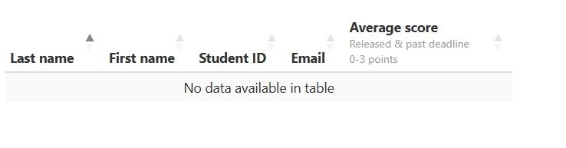
  + Is student ID == WID?
  + Is student email == K-State email?
  + *We need a test K-State student to research this*
* **Export Data:**
  + Allows for the downloading of:
    - All uploaded content
      * Includes all documents that have been uploaded into a zip file.
        + This does not include Perusall catalog books.
    - All comments
      * Spreadsheet of all comments by:
        + Students
        + Instructors
        + Teaching assistants
      * Assignment information
        + Downloads information about each assignment in the course as a CSV file.
      * All course data
* **Student View**
  + Creates a student account that gets enrolled on the course and remains until removed. This account is used to view the class through the eyes of a student.
* **Chats:**
  + Can create chat rooms that students can engage with each other.
    - These chat rooms can be open to all instructors and students, or they can be available to only the creator and other people that are specified.
  + There are 2 chat rooms upon creation of a class, Announcements and General Discussion.
* **One-on-One:**
  + Can create one-on-one discussions with other individuals in the course.

**Questions:**

* Can we automate the pulling, reading, and storing of the information from the Export Data page?
* Is the student ID and email the same as K-State WID and K-State email?
* Are we able to pull information straight from the Perusall API?
  + Will be sending an email to Perusall support about this.